**Case Study: How Does a Bike-Share Navigate Speedy Success?**



**Background**

In 2016, Cyclistic launched a successful bike-share offering. Since then, the program has grown to a fleet of 5,824 bicycles that are geotracked and locked into a network of 692 stations across Chicago. The bikes can be unlocked from one station and returned to any other station in the system anytime. Until now, Cyclistic’s marketing strategy relied on building general awareness and appealing to broad consumer segments. One approach that helped make these things possible was the flexibility of its pricing plans: single-ride passes, full-day passes, and annual memberships. Customers who purchase single-ride or full-day passes are referred to as casual riders. Customers who purchase annual memberships are Cyclistic members. Cyclistic’s finance analysts have concluded that annual members are much more profitable than casual riders. Although the pricing flexibility helps Cyclistic attract more customers, the manager believes that maximizing the number of annual members will be key to future growth.

Rather than creating a marketing campaign that targets all-new customers, the manager believes there is a very good chance to convert casual riders into members. He notes that casual riders are already aware of the Cyclistic program and have chosen Cyclistic for their mobility needs. Manager has set a clear goal: Design marketing strategies aimed at converting casual riders into annual members. In order to do that, however, the marketing analyst team needs to better understand how annual members and casual riders differ, and why casual riders would buy a membership. Upper management team is interested in analyzing the Cyclistic historical bike trip data to identify trends.

**Business Task**

It’s to analyze characteristics of annual members and casual riders and the behaviors on how they use Cyclistic bikes differently.

## **Prepare Data for Exploration**

* From January 2022 to December 2022, twelve-month datasets were downloaded and used in total. These datasets are available at <https://divvy-tripdata.s3.amazonaws.com/index.html>
* The datasets were in CSV file format.

**Process Data from Dirty to Clean**

Programs used:

* Excel for initial data inspection
* Microsoft SQL Server Management Studio (SSMS)

Data cleaning walkthrough:

* Combined all 12-month bike-share datasets and creating a new table named "bikeshare_2022"
* Found outliers in started_at and ended_at columns. Remove all outliers where ended_at is smaller than started_at
* Removed all duplicates
* Removed all null values
* Created a new and clean table “bikeshare_2022”

**Analyze**

1. Added and calculated a new column “ride_length”
2. Added and calculated a new column “day_of_week”
3. Calculated the average ride_length for casual and member riders
4. Calculated the max ride_length
5. Calculated the number of trips by type of riders
6. Calculated the number of trips by type of riders by day_of_week
7. Calculated number of different rideable_type for riders
8. Found out where member and casual riders starting and ending their trips
9. Found out the popular months by member and casual riders

**Summary of Analysis**

1. There are three types of bikes available for riders: classic, electric, and docked. The analysis indicates that both types of riders tend to prefer the classic bike, followed by the electric bike. The majority of member riders only use classic and electric bikes, with only 0.52% of them using docked bikes. In contrast, about 9% of casual riders use docked bikes. These findings suggest that classic and electric bikes are the most popular among riders, particularly for members, while docked bikes are less popular and are preferred more by casual riders.
2. The analysis indicates that the average ride length for casual riders is 23.4 minutes, while it is 13.1 minutes for member riders. These findings suggest that casual riders tend to take longer rides on average than member riders.
3. Although the data shows that the average ride length for member riders is significantly lower at 13.15 minutes compared to casual riders' average of 23.42 minutes, the number of trips taken by member riders is much higher at 2,581,436, compared to 1,740,019 for casual riders. This suggests that member riders utilize the service more frequently, which could be attributed to the fact that they have already paid the membership fee and do not have to pay an initial fee to rent the bikes.
4. Based on our analysis, we found that Saturday is the most popular day of the week for casual riders, with a total of 353,496 trips. This is followed by Sunday, with 293,127 trips, and Friday, with 242,983 trips. These results suggest that casual riders tend to use the bike-sharing service more frequently on weekends. In contrast, I found that member riders prefer weekdays over weekends. Specifically, Thursday, Wednesday, and Tuesday are the most popular days for member riders to use the service. The findings indicate that there are significant differences in rider preferences for different days of the week. From a cost-effective perspective, it may be beneficial for riders who need to rent bikes regularly for work or commuting purposes to consider purchasing a membership pass. Similarly, those who primarily use the service on weekends or infrequently may find it more cost-effective to continue renting bikes on a casual basis. (Visualization 1)
5. The results indicate possible seasonal and weather-related pattern that summer is the most popular season for both member and casual riders, with the highest total number of rides. However, there are some differences in the most popular months between the two groups. For member riders, the top three most popular months are August, July, and June, respectively. In contrast, for casual riders, the top three most popular months are July, June, and August. Both groups show a lower demand during the winter months, specifically December, February, and January, likely due to the cold winter weather. (Visualization 2)
6. According to the analysis, the top five start stations for casual riders are:
   1. Streeter Dr & Grand Ave
   2. DuSable Lake Shore Dr & Monroe St
   3. Michigan Ave & Oak St
   4. Millennium Park
   5. Montrose Harbor

For member riders, the top five start stations are:

1. Ellis Ave & 60th St
2. University Ave & 57th St
3. Ellis Ave & 55th St
4. State St & 33rd St
5. Calumet Ave & 33rd St

The analysis of Tableau visualization 3 reveals that casual riders predominantly choose to rent bikes in the downtown Chicago , specifically along the harbors. This pattern strongly suggests that these riders opt for bike rentals primarily for leisure purposes. On the other hand, member riders frequently initiate their rides from residential neighborhoods, suggesting a potential commuting purpose and a consistent requirement for bikes on a daily basis. This observation provides insight into why these individuals opt for membership passes, as it correlates with their regular usage patterns. (Visualization 3)

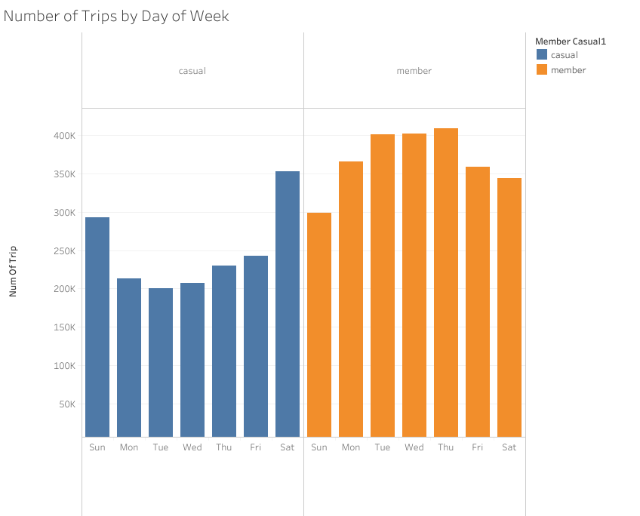

Visualization 1

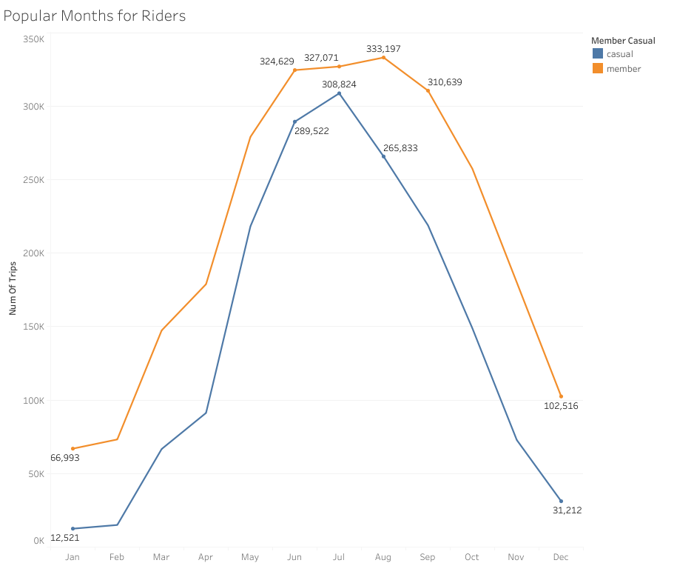

Visualization 2

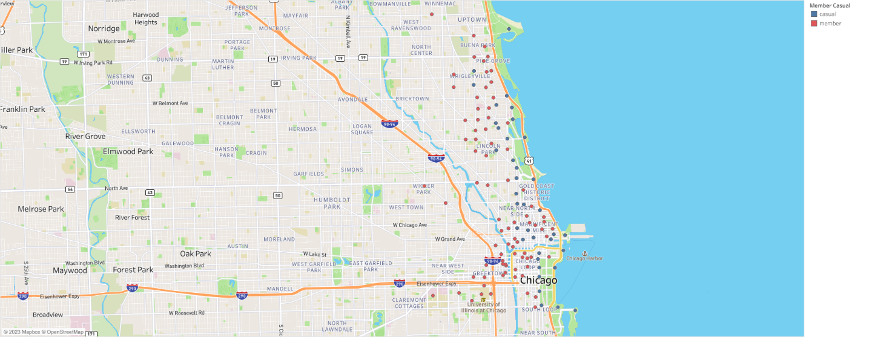

Visualization 3